**LEEDS-BASED FOLK ARTIST**

**RHIANNON HOPE**

**TO ANNOUNCE DEBUT EP**

***ALL THINGS, RISING AND RETURNING***

**OUT 25TH SEPT VIA PRIVATE REGCORDS**

**LEAD SINGLE ‘B.B.’ ARRIVES 4TH SEPT**

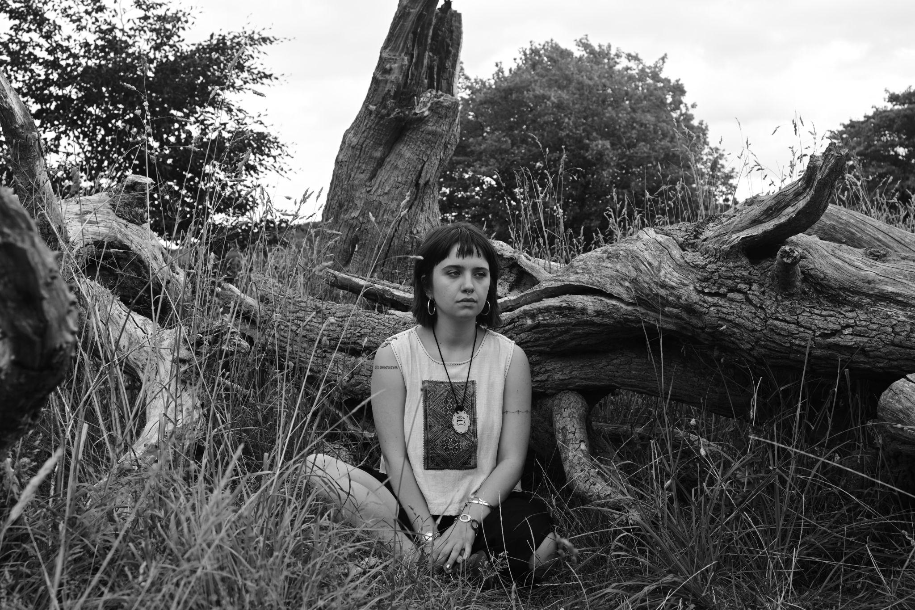

*Credit: Noah Lakehal, hi-res* [*here*](https://drive.google.com/file/d/1ZPovMT-xnS35MCu4xLw0PD-DNUe3F6dn/view?usp=sharing)

**Liverpool-born, Leeds-based folk songwriter Rhiannon Hope will be announcing her first EP, *All Things, Rising and Returning*, next week. The EP arrives this September via Private Regcords.**

Weaving odes to jazz greats into tales of the working class experience and stitching gentle twangs into accordion hums, ***All Things, Rising and Returning*** marks the debut release from Leeds-based folk artist **Rhiannon Hope**. The EP nurtures a unique blend of traditional folk and contemporary influences, with Rhiannon looking to the likes of Ella Fitzgerald and Aldous Harding for sonic guidance. The resulting sound is at once delicate and deliberate, wistful yet soulful, and, perhaps most of all, timeless.

Lead single **‘B.B’** arrives in a couple of weeks time and shows off Hope’s talent for melody and intimacy in her approach to folk. Softly-picked strings form a tapestry of sound around Hope’s enchanting harmonies, as she examines her place in the world. *“‘B.B.’, at its core, is about imposter syndrome,”* explains Rhiannon, *“yet simultaneously being welcomed with open arms, and not knowing how to compute these two very strong emotions - it's about feeling very different and being very aware of that. Perhaps it is a form of self-soothing, of reassurance for myself.”*

‘B.B.’ arrives on 4th September. Listen to an advance stream [**here**](https://drive.google.com/file/d/1QDM6kXazXwpH4YvVW5yVq_5PJ81Nh8vW/view?usp=sharing) (please do not share).

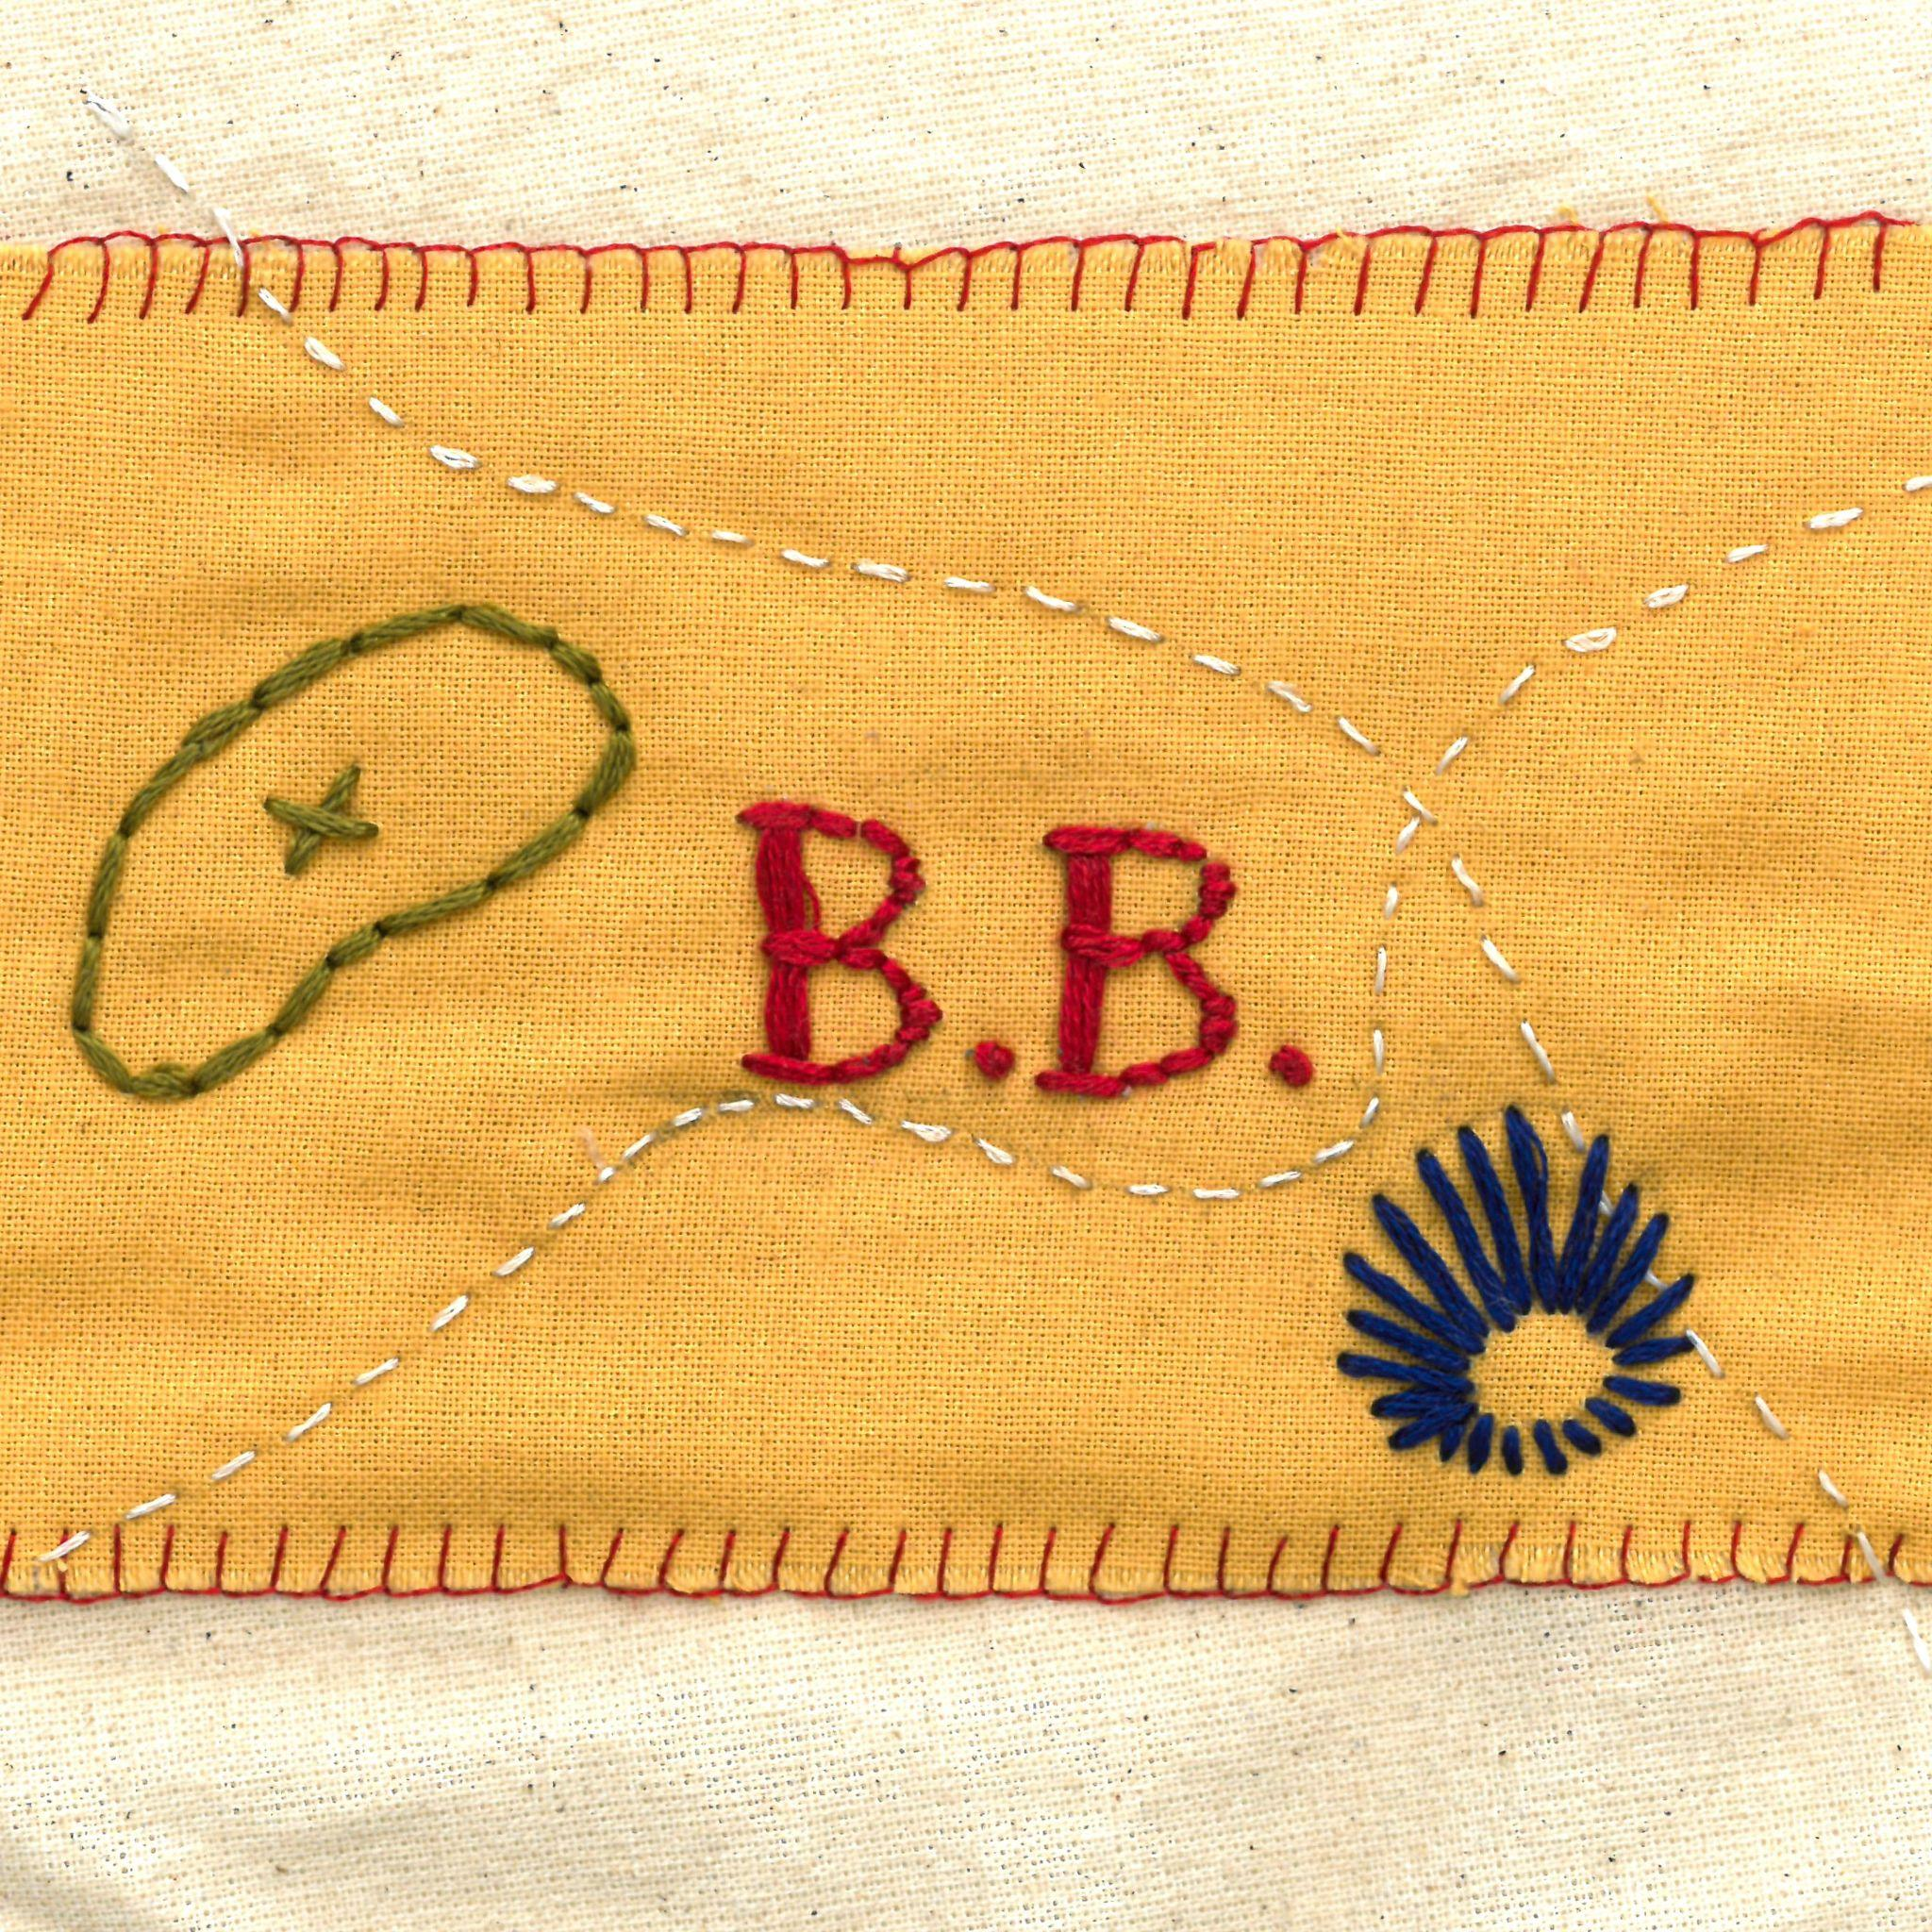

‘B.B.’ single artwork

Following the release of ‘B.B.’, Rhiannon’s debut EP, *All Things, Rising and Returning*, will arrive digitally and on vinyl on **25th September** via Private Regcords.

On the eponymous track, Hope pairs her strong, swirling vocals with the gentle whirrs of an accordion, evoking all the ethereality of the release title, while ‘Indulge’ builds upon the beauty of ‘B.B.’ with playful plucks and strengthened vocal prowess. Physical copies of the EP will feature a bonus track, a live recording of ‘Toothpaste’ recorded at Hyde Park Book Club in Leeds, as well as artwork created by Rhiannon herself.

*“I feel things are becoming rapidly impersonal and abstract, and so with the cover art for All Things, Rising and Returning, I wanted it to be as tactile an experience as possible,”* she explains, *“as a kind of gentle rebellion. Everything about the record is physical: it was recorded live, the cover art, both single and EP are embroidered by me, the songs came together slowly through playing with the band; even most of the instruments are acoustic. In a world where media is becoming so fast-paced and often short-lived, I want All Things, Rising and Returning to act as a break from the need to rush - taking time with things should not be underestimated or devalued.”*

The songs have been pressed onto wax by Vinyl Press, which will mark the first vinyl release both for Rhiannon and for Leeds-based label Private Regcords. But the record feels far stronger than most debuts, carrying a sense of intention in its songwriting and production that most artists only hone much later into their discographies. On her first EP, Rhiannon Hope may not be returning, but she’s certainly rising.

***All Things, Rising and Returning* Tracklist:**

1. All Things, Rising and Returning
2. B.B.
3. Indulge
4. Toothpaste (Live)*

*only included on physical copies

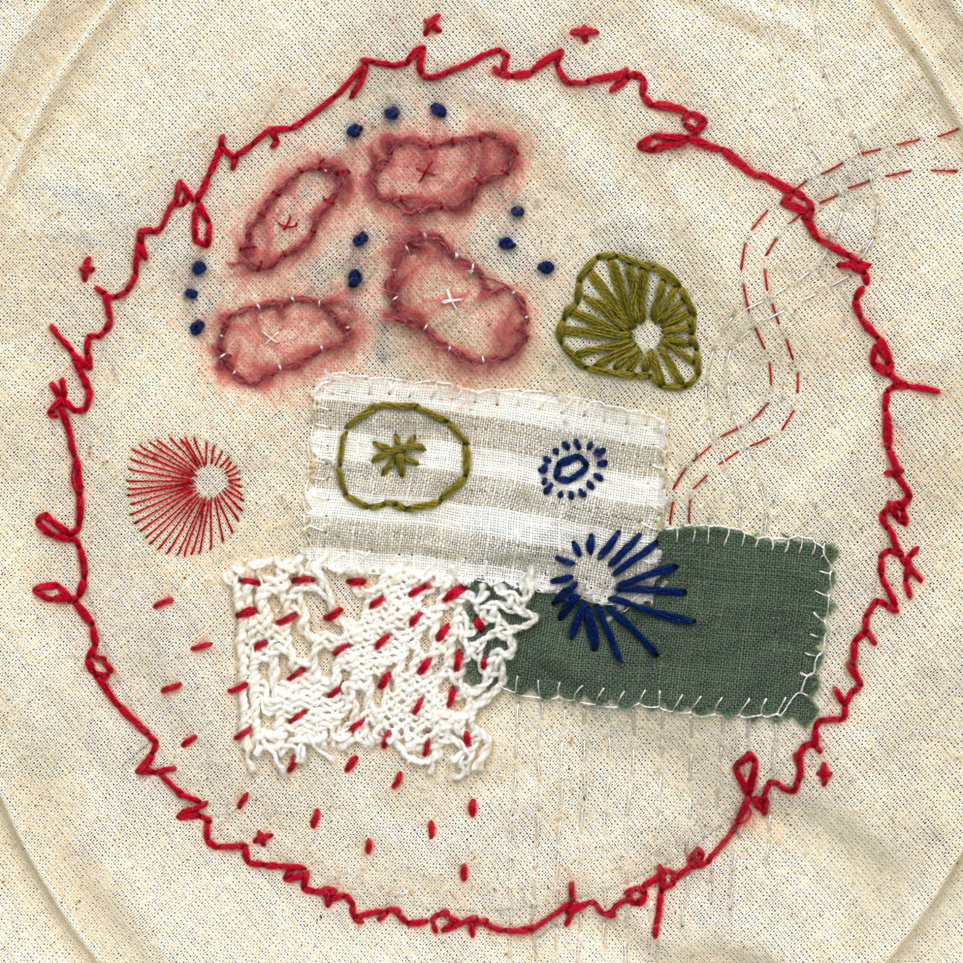

*All Things, Rising and Returning artwork*

**About Rhiannon Hope**

Helming from Leeds-via-Liverpool, Rhiannon Hope has quickly found her footing in Yorkshire’s grassroots scene, collecting a unique band of multi-instrumentalists along the way. Together, they create textured, jazz-influenced folk soundscapes which act as a bed for Rhiannon’s bittersweet experiences of womanhood, identity and the working class. Somewhere between her unfaltering vibrato and intimate songwriting, Hope has earned a loyal following in her adopted city, as well as a tour support spot with Gal Go (of King Krule).

Surrounding the release of *All Things, Rising and Returning*, Hope will return to the road for a run of dates throughout September. On the 6th, she plays her first show at Leeds’ most beloved venue, the Brudenell, alongside fellow folk aficionados Green Gardens. Later in the month, she headlines the snug at Hyde Park Book Club, as well as venturing further afield to The Grove in Nottingham and The Windmill in London. Full listings can be found below.

Guestlist, full EP streams and interviews available upon request.

**Live dates:**

6th September – Brudenell Social Club, Leeds*

19th September – Alder, Sheffield

27th September – The Snug, Hyde Park Book Club

28th September - The Grove, Nottingham

29th September – The Windmill, London

*support slot with Green Gardens

**For more information:**

[LinkTree](https://linktr.ee/privatereg) | [Instagram](https://www.instagram.com/rhiannonh0pe/)

**Or please contact:**

[elle_palmer@msn.com](mailto:elle_palmer@msn.com) / [privateregproject@gmail.com](mailto:privateregproject@gmail.com)

